Investigating Predictive Factors in the Performance of Credit Card Companies
Elizabeth Kwee

Abstract
This paper attempted to predict the performance of the two largest credit card companies – Visa and Mastercard – by various macroeconomic and industry-specific indicators ranging from unemployment rate and real GDP to number of cards and number of cash transactions. Quarterly data from the end of 2011 to the second quarter of 2024 were taken to this end, and revenue was chosen to represent the companies’ performance. Visa was found to have a final model including number of cash transactions, number of purchase transactions, unemployment rate, and three-month interest rate while Mastercard’s revenue could best be predicted by real GDP, CPI less food and energy, unemployment level, and three-month interest rate. The results show that even companies in the same industry cannot all be explained by the same information. Additionally, we see that variables that are seemingly not as closely related to the companies still predict performance well, opening the possibility of further expanding the range of predictors in the future.

Introduction
The sphere of investing has been in focus for decades; many are drawn by the possibility of earning money while not actively spending their time and labor. However, choosing investments wisely is not simple. With such a diverse range of publicly traded companies, from Chipotle to Microsoft, no set method exists to unearth the ideal company for investment. Indeed, if such a method did exist, every investor would have a direct route to those “ideal” companies, leading to increased stock market prices and making them no longer the best decisions. Because of the difficulty in choosing companies, some make their livings as investment advisors, providing their clients, in exchange for a fee or a portion of the profits, with information on what companies their clients should invest in. However, in addition to other drawbacks, investors using investment advisors would start off with an initial loss of potential profit. For this reason, investors being able to conduct their own analyses on potential return would lead to the ability for them to make both more assured and profitable decisions.
As previously mentioned, however, the amount of variability between industries makes a generic analysis inaccurate at best. For example, restaurants generally have lower profit margins than insurance companies (Profit margin by industry, n.d.) – that is, restaurants retain less profit for the same revenue – but that does not suggest that they are an inherently inferior investment. Industry-specific factors, therefore, are also important to conducting financial analysis.
Research Question
Because of this variability in industries, this paper will focus on only one industry: credit card companies. It will investigate which factors – either industry-specific or macroeconomic – are predictive in Visa and Mastercard’s performance, measured by revenue. Some predictive factors that will be investigated are gross domestic product (GDP), inflation, and unemployment rate, as well as industry-specific elements such as the number of debit and credit cards, gross dollar volume (GDV), or number of transactions.
Statement of Purpose
In 2005, Visa and Mastercard had a class action lawsuit filed against them over their allegedly artificially high interchange fees (Stempel, 2024) – the fees merchants pay the credit card companies for using their services– with plaintiffs arguing anti-competitive, collusive practices possible through the two companies controlling most of the industry. Earlier in the year that this paper was written, Visa and Mastercard’s attempted settlement was rejected, and the companies are likely to continue to a trial, as Stempel (2024) continues to report. In the face of the recent uncertainty, it is possible that potential investors are hesitant to buy Visa and Mastercard stock. However, as businessman and Berkshire Hathaway CEO Warren Buffett famously advised, “Be fearful when others are greedy and greedy when others are fearful.”
Even as this could be an opportune moment to purchase, just as with any other investments, one of several other important factors to investigate is the potential for growth. If a model can be created that predicts the next period’s performance, investors can predict future performance given certain factors in the present period, giving them a ‘crystal ball’ to make informed decisions before the financial statements are released.

Literature Review
In one journal article from the International Journal of Advanced and Applied Sciences, authors Boron, Villarba, Murcia, and Delima (2023) investigate how the transparency of Philippine companies’ Internet reporting affected market performance, measured by 1) stock price, 2) stock returns, and 3) company value – that is, market value (Boron et al., 2023, p. 18). They found that, although no significant effect on stock price or company value was found, a positive correlation between the companies’ Internet transparency and their earnings per share – stock returns – existed (Boron et al., 2023, p. 21). Like our topic of interest, this article attempts to find a pattern between some quantifiable factor and companies’ performance. Additionally, though no pattern relating to two response variables appeared, the authors still discovered it for one. This shows that, while a predictor may not initially appear relevant, there may be a closely related, significant variable that could easily be overlooked.
More closely related to this paper’s topic, authors Issah and Antwi (2017) explore how 59 macroeconomic variables – population, interest rate, real GDP, and more (Issah & Antwi, 2017, pp. 15-16) – affect UK firms’ performance (Issah & Antwi, 2017, p. 2), measured by return on asset (ROA) (Issah & Antwi, 2017, p. 1). This was one factor of the paper that the authors especially focused on in the conceptual framework: the rationale behind their choice of response variable (Issah & Antwi, 2017, pp. 3-4). Because the choice is not arbitrary, the audience likely would feel greater confidence that the result, whether significant or not, is reliable. Additionally, the authors take care to divide their sample into industry-specific categories in addition to measuring the full sample (Issah & Antwi, 2017, pp. 4-5). They discover that five of the six categories as well as the full sample have a strong r2 value; macroeconomic factors are significant in explaining firms’ performance (Issah & Antwi, 2017, p. 12).
In a similar vein but in a different part of the world, authors Seo, Kim, Bang, and Kang (2024) focus on measuring the performance of South Korean construction companies, using financial statement data with over 150 variables (Seo et al., 2024, p. 11). After narrowing down the number of predictors to 35 (Seo et al., 2024, p. 4), the authors determined the seven most significant variables impacting performance for construction companies (Seo et al., 2024, p. 11). Among these were total asset turnover most significantly impacting ROA while sales and government expenses most greatly impacted enterprise value per share (EV/S) (Seo et al., 2024, p. 11). One thing this article especially appeared to do well was consider every aspect, enumerating weaknesses in the model such as lack of non-financial factors (Seo et al., 2024, pp. 11-12) and lack of prediction power (Seo et al., 2024, p. 11).
In all three articles, the authors took care to consider more than one perspective. For example, in the Philippine article, considering more than one market performance indicator led to the discovery of significance in one of the three (Boron et al., 2023, p. 21). In the UK article, the authors broke their sample into six industries, testing them individually as well as testing the full sample (Issah & Antwi, 2017, pp. 4-5). This led to the discovery of one of the six industries not showing a strong r² value despite the full sample showing such (Issah & Antwi, 2017, p. 12). Finally, the article focusing on South Korean construction companies spent a significant amount of time specifying their reasoning for their choices of predictors (Seo et al., 2024, pp. 6-7) and clarifying the limitations of their study (Seo et al., 2024, pp. 11-12). Because of this, each of the papers gains more credibility as the authors lead the audience through their justifications for each choice. Overall, all three articles discover some level of significance, whether in one key area with the Philippine paper (Boron et al., 2023, p. 21) or in most areas after searching for the most significant predictors (Issah & Antwi, 2017, p. 12; Seo et al., 2024, p. 11).
At the same time, however, as just touched on, how each study analyzes their data varies. While the Philippine paper has a more straightforward analysis, mainly just separating the samples into sectors before standardizing the market performance indicators (Boron et al., 2023, pp. 19-21), the UK firms’ paper authors transform some of the predictors (Issah & Antwi, 2017, p. 5) before spending a lot of effort testing for the most significant predictors (Issah & Antwi, 2017, pp. 7-12). While the South Korean paper – similar to the UK one – performs significant analysis narrowing the number of variables down (Seo et al., 2024, pp. 6-10), one large focus is on utilizing the model on manufacturing companies to check whether the fit for the construction companies is significant (Seo et al., 2024, pp. 7-8).

Methodology
Description of population and data collection
The populations of interest are the credit card companies being analyzed: Mastercard and Visa. While Discover and American Express are also major companies in the industry, Mastercard and Visa are the largest, with revenues in the second quarter of 2024 of $7 billion (Mastercard Incorporated, 2024) and $8.9 billion respectively (Visa Inc., 2024a) versus Discover with $5.1 billion (Discover Financial Services, 2024) and American Express with $6.1 billion (American Express Company, 2024) in the third quarter of 2024. While the results would not be generalizable beyond each company being analyzed, the aim of this paper is to predict performance for the specific companies, not an industry.
All five data sets contain 51 observations – each containing the information from quarterly – ranging from the fourth quarter of 2011 to the second quarter of 2024. Each observation includes the operational data, revenue and net income, or macroeconomic indicators corresponding to the date. To ensure the legitimacy of the information, the credit card companies’ operational and financial data were obtained through their “Investor Relations” pages. The information for the macroeconomic indicators was collected from the Federal Reserve Economic Data (or FRED) online database, which aggregates data mainly from government agencies.
All the data was collected by transferring the information from the pages into a data table.
Description of variables
Visa and Mastercard’s operational data contained breakdowns – by geographic region and by credit and debit – of all the industry-specific variables to be mentioned, but for the purposes of this analysis, only the worldwide, combined credit and debit numbers will be considered.
The following are the industry-specific variables:
- The total number of credit and debit cards held (in millions).
- The total number of cash transactions (in millions). This would include ATM and similar cash payments (Visa Inc., 2024b).
- The total volume of cash transactions (in billions of dollars), showing the amount of money moved in the cash transactions (Visa Inc., 2024b).
- The total number of payments transactions (in millions). This shows the number of purchases made with cards (Visa Inc., 2024b).
- The total volume of payments transactions (in billions of dollars). Like cash volume, this describes the amount of money moved in purchase transactions (Visa Inc., 2024b).
- Gross dollar volume (shortened to GDV), also called total volume (in billions of dollars). This represents the sum of payments and cash volume, and therefore is the total amount of money moved by the company over the quarter (Visa Inc., 2024b).
To account for variables beyond the industry, a wider range of factors will also be considered in the analysis to measure the country’s socioeconomic performance. The following are some of the possible options, all being quantitative:
- S&P 500 stock price (in tens of dollars).
- Nominal GDP (in billions of dollars). This shows the total volume of goods and services in the United States over the quarter.
- Consumer price index (CPI). This compares the price of goods and services over time, measuring inflation over time for those goods and services (U.S. Bureau of Labor Statistics, n.d.-a).
- Personal consumption expenditures (PCE). This is the price index measuring the prices people in the U.S. pay for goods and services (U.S. Bureau of Economic Analysis, n.d.-b).
- Unemployment rate (in percentage), representing the number of unemployed as a percentage of the labor force (U.S. Bureau of Labor Statistics, n.d.-b). This would be a number between 0 and 100.
The response variable, which will be representative of the companies’ performance, will be revenue (measured in dollars). As alluded to, other options considered were net income (measured in dollars); return on assets; or earnings before interest, taxes, depreciation, and amortization (EBITDA) (measured in dollars). However, these are more open to variability. EBITDA is loosely defined as revenue less operating expenses, meaning it is dependent on company activities such as research and development expenses. Unlike net income – which is also a factor in calculating return on assets and earnings per share – revenue is unaffected by investments in research and development; property, plant, and equipment; and other one-off or variable expenditures. Therefore, revenue appears to be the best indicator of the company’s overall performance in the long run.
Analysis plan
Since a major part of the paper is investigating the factors that are predictive in the credit card companies’ performance, the exact model used to predict performance has not yet been determined. Multiple regression will be utilized to achieve the most accurate predictive model, with the maximum model being as follows:
$$Y= β_{0}+β_{1}X_{1}+β_{2}X_{2}+…+B_{17}X_{17}+E$$
Every X_{i} is a possible predictor, including all of them in the maximum model.
To aim to achieve the most precise model, we will use forward selection, backward elimination, and stepwise selection, afterwards deciding on the best if they differ. Additionally, because of the large number of predictors, it is less difficult to remove predictors by hand than to add them, and therefore we will use the Akaike Information Criterion (AIC) in selecting our model.
After selecting our final model, we will check the regression conditions for multiple regression: normality, linearity, and homoscedasticity. Since we have such a wide choice of predictors, it is not unlikely that a condition may not be met. If it is discovered that one of the conditions is, in fact, not met, we can perform the appropriate transformation on the data.

Results
The purpose of this paper was to determine whether we could predict Visa and/or Mastercard’s quarterly revenue from various industry-specific and macroeconomic factors, also measured quarterly, from the fourth quarter of 2011 to the second quarter of 2024. We decided to analyze this topic to determine how external and internal factors might or might not affect each companies’ performance, even as they face uncertainty with a pending lawsuit.
Descriptive Statistics
From the end of 2011 to the middle of 2024, Visa’s revenue grew 3.5 times ($2.55 billion to $8.9 billion) in comparison to Mastercard’s quadrupled revenue ($1.73 billion to nearly $7 billion). Given Visa’s larger figures, the company unsurprisingly has a larger mean revenue ($5.1 billion vs. $3.66 billion) and larger standard deviation ($1.9 billion vs. $1.5 billion) than Mastercard.
Additionally, both companies show a generally consistent positive trend over time (Figures 1 and 2), only dropping temporarily in 2020 before returning to a consistent growth.

Figures 1 and 2
Visa and Mastercard’s revenue over time
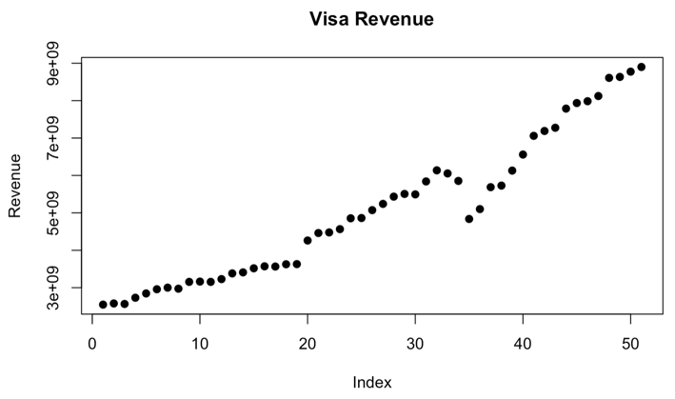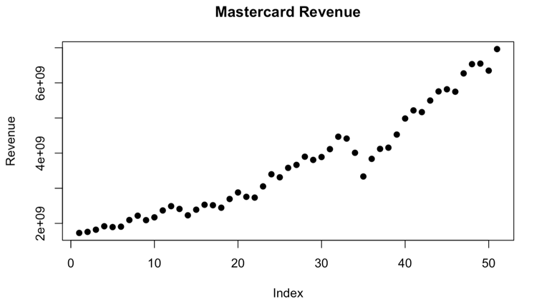

Most of the potential predictors have strong correlations above r = 0.9 with revenue, and nearly all have at least a moderately strong correlation, two major exceptions being cash transactions (r = 0.222) and cash volume (r = 0.014) for Visa. Additionally, the only variables with a negative correlation with revenue are unemployment rate (r = -0.663 for Visa and r = -0.637 for Mastercard) and unemployment level (r = -0.626 for Visa, r = -0.601 for Mastercard).

Table 1
Revenue correlation with predictors
Variable | Visa Correlation | Mastercard Correlation
Cards | 0.976 | 0.979
Cash transactions | 0.222 | 0.782
Cash volume  Gross dollar volume | 0.014  0.972 | 0.861  0.992
Purchase transactions | 0.982 | 0.989
Purchase volume | 0.981 | 0.991
S&P 500 | 0.943 | 0.949
Nominal GDP  Real GDP  Real GDP per capita  Consumer price index  CPI less food energy  Personal consumption  Unemployment rate  Unemployment level  3-month interest rate  10-year interest rate | 0.991  0.988  0.987  0.974  0.788  0.987  -0.663  -0.626  0.811  0.522 | 0.993  0.983  0.985  0.981  0.789  0.990  -0.637  -0.601  0.812  0.532

In general, apart from cash transactions and cash volume, the predictors appear to show similar strengths of relationships to revenue regardless of company. However, in line with the company’s larger size, Visa’s predictors generally have larger values than Mastercard’s (Table 2).

Table 2
Median, mean, and standard deviations of Visa (V) and Mastercard (MA) predictors (n = 51)
Variables | V_Median | V_Mean | V_SD | MA_Median | MA_Mean | MA_SD
Cards | 3267 | 3165 | 782 | 1837 | 1924 | 600
Cash trans. | 4318 | 4531 | 674 | 2986 | 2754 | 632
Cash volume  GDV | 645  2755 | 653  2641 | 58  765 | 376  1404 | 357  1492 | 68  454
Purchase trans | 39320 | 39715 | 17692 | 20542 | 23768 | 11467
Purchase volume | 2019 | 1989 | 757 | 1037 | 1135 | 396
S&P 500 | 258 | 284 | 112 | - | - | -
Nominal GDP  Real GDP  Real GDP per capita  CPI  CPI less food energy  Personal cons.  Unemp. rate  Unemp. level  3-month int. rate  10-year int. rate | 20037  19882  60674  250  2.39  13793  4.70  7659  0.21  2.32 | 20924  19947  60998  257  2.86  14159  5.26  8407  1.24  2.36 | 3820  1754  4132  26  1.32  2556  1.76  2656  1.73  0.92 | -  -  -  -  -  -  -  -  -  - | -  -  -  -  -  -  -  -  -  - | -  -  -  -  -  -  -  -  -  -

It is known that many of the potential predictors are closely related. As a few examples, cash volume plus purchase volume is GDV, and unemployment rate and unemployment level would have very similar trends, as would nominal GDP, real GDP, and real GDP per capita. In fact, we find that every predictor’s variance inflation factor (VIF) in the full model – containing all industry-specific and macroeconomic factors – is above or significantly above 10 (Table 3), indicating severe collinearity. However, two variables with especially extreme VIFs are GDV (Visa with 1367134 and Mastercard with 878775) and purchase volume (1330820 and 669434, respectively). Therefore, collinearity must be considered when selecting a model.

Table 3
Variance inflation factors (VIFs) of predictors in full Visa and Mastercard models
Variables | Visa VIFs | Mastercard VIFs
Cards  Cash transactions  Cash volume  Gross dollar volume | 260  69.6  8022  1367134 | 1505  431  19326  878775
Purchase transactions | 930 | 862
Purchase volume | 1330820 | 669434
S&P 500 | 77.3 | 81.7
Nominal GDP  Real GDP  Real GDP per capita  Consumer price index  CPI less food energy  Personal consumption  Unemployment rate  Unemployment level  3-month interest rate  10-year interest rate | 5591  2364  1822  2085  27.1  666  383  3456  13.1  11.5 | 7754  20266  11780  1759  26.1  642  3954.4  3612  14.5  11.2

Inferential Statistics
Visa model selection
We conducted forward selection, backward elimination, and stepwise selection on the Visa data to get the following results:
Forward selection resulted in an AIC of 1921 with final predictors of nominal GDP, cash transaction, purchase transactions, three-month interest rate, unemployment rate, unemployment level, consumer price index, real GDP, and purchase volume. While the final model is significant in predicting revenue (F = 1059 with 9 and 41 degrees of freedom, p < 2.2 x 10⁻¹⁶), nine of the ten predictors still have VIFs above 10, indicating that collinearity was not fixed.
With backward elimination we found an AIC of 1919.4 with final predictors of cash transactions, gross dollar volume, purchase transactions, purchase volume, nominal GDP, real GDP, real GDP per capita, consumer price index, unemployment, and three-month interest rate. Similarly, although the model predicts revenue well (F = 997.7 with 10 and 40 degrees of freedom, p < 2.2 x 10⁻¹⁶), all but one of the predictors indicate severe collinearity issues remaining.
Finally, using stepwise selection resulted in an AIC of 1929.3 with final predictors of cash transactions, purchase transactions, three-month interest rate, unemployment rate, and unemployment level. This final model is much closer to having no collinearity issues while remaining significant in predicting revenue (F = 1517 with 5 and 45 degrees of freedom, p < 2.2 x 10⁻¹⁶), but two of the five predictors have VIFs far above 10.
In short, all three final models from model selection algorithms contained different predictors while still having collinearity issues, with the least problematic model being the one chosen through stepwise selection. However, by removing unemployment level – since unemployment rate and level are so closely correlated – we get a final model with cash transactions, purchase transactions, three-month interest rate, and unemployment rate. While AIC is higher than the other models (1937.8), this model still is equally significant in predicting revenue (F = 1576 with 4 and 46 degrees of freedom, p < 2.2 x 10⁻¹⁶), and the largest VIF is 3.
Therefore, our final model is as follows:
$$Y= β_{2}X_{2}+β_{5}X_{5}+β_{14}X_{14}+β_{16}X_{16}+E$$
with the variables defined as follows:
- X₂ is the number of cash transactions
- X₅ is the number of purchase transactions
- X₁₄ is the unemployment rate
- X₁₆ is the three-month interest rate
The model has the following outputs:
Table 4
Visa final model coefficient outputs
 | Estimate | SE | t value | p
(Intercept) | 3.79 x 10⁹ | 3.43 x 10⁸ | 11.05 | 1.54 x 10⁻¹⁴
Cash transactions  Purchase transactions | -3.49 x 10⁵  8.92 x 10⁴ | 4.92 x 10⁴  2124 | -7.09  41.99 | 6.62 x 10⁻⁹  1.02 x 10⁻⁸
3-month interest rate | 1.55 x 10⁸ | 2.23 x 10⁷ | 6.97 | 1.02 x 10⁻⁹
Unemployment rate | -1.60 x 10⁸ | 2.37 x 10⁷ | -6.742 | 2.23 x 10⁻⁸

Additionally, the final model has a multiple r² value of 0.991, indicating that nearly all the variation in revenue can be explained by the four predictors.
To check that inference can be performed on this model, we will check linearity, homoscedasticity, and normality.
The residual plot of the data (Figure 3) shows no obvious pattern, so linearity is satisfied. Similarly, since the residuals are mostly evenly scattered around 0, homoscedasticity is also satisfied. The two possible outliers do not significantly alter the pattern of the data. Although we see that they are influential points by Cook’s Distance – the point with a residual of about 4 and the point with a residual of about -4 – since both are above the cutoff of 4/51, so they can be analyzed to check whether they should be removed. Since the intercept changed by over 1 standard error, we should remove the influential points from the model.

Figure 3
Residual plot of final Visa model
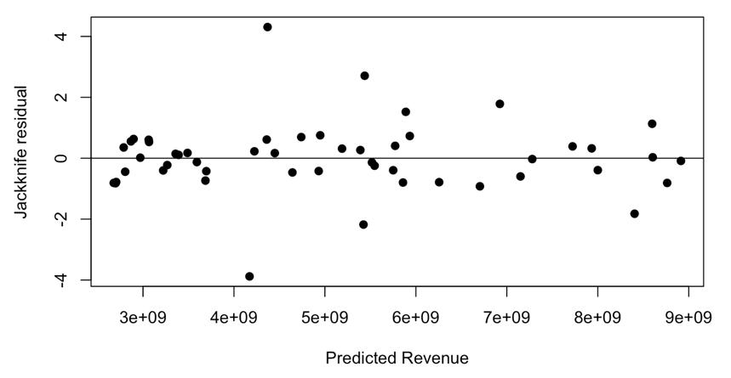

Additionally, a normal probability plot of the data (Figure 6) does not show any significant concave pattern as most of the data follows a straight line, so normality also holds.

Figure 4
Normal probability plot of final Visa model
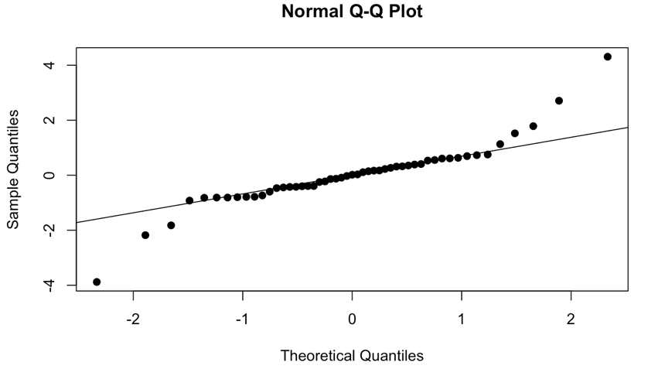
Mastercard model selection
Using forward selection on the Mastercard data, we found an AIC of 1889 with final predictors of nominal GDP, GDV, three-month interest rate, purchase volume, CPI, real GDP, purchase transactions, and cards. While this model is significant in predicting revenue (F = 1345 with 8 and 42 degrees of freedom, p < 2.2 x 10⁻¹⁶), significant collinearity still exists, with seven of the eight remaining predictors having VIFs in either the hundreds or thousands.
With backward elimination, we found an AIC of 1887 with final predictors of cards, GDV, purchase transactions, purchase volume, CPI, CPI less food and energy, unemployment level, and three-month interest rate. Again, we see severe collinearity issues in six of eight predictors with VIFs in the thousands, even though the model is significant in predicting revenue (F = 1421 with 8 and 42 degrees of freedom, p < 2.2 x 10⁻¹⁶).
Finally, using stepwise selection resulted in an AIC of 1892 with final predictors of nominal GDP, three-month interest rate, CPI, real GDP, purchase transactions, unemployment level, and CPI less food and energy. Four of the seven predictors still have severe collinearity issues with VIFs of 130, 536, and 2584, although the model is similarly significant in predicting revenue (F = 1439 with 7 and 43 degrees of freedom, p < 2.2 x 10⁻¹⁶).
As with the final models with the Visa selection algorithms, all three models found with selection algorithms contained different predictors and still had collinearity issues, the model with least issues being the one selected through stepwise selection. Following the same process as with Visa, after we removed nominal GDP, purchase transactions, and CPI, we discovered a final model containing three-month interest rate, real GDP, unemployment level, and CPI less food and energy. With this model, we no longer observe collinearity – the largest VIF was 3.2 – and we have a significant model (F = 1220 with 4 and 46 degrees of freedom, p < 2.2 x 10⁻¹⁶).
Here, our final model is as follows:
$$Y= β_{9}X_{9}+β_{12}X_{12}+β_{15}X_{15}+β_{16}X_{16}+E$$
with the variables defined as follows:
- X₉ is the real GDP
- X₁₂ is the CPI less food and energy
- X₁₅ is the unemployment level
- X₁₆ is the three-month interest rate
This model has these outputs:
Table 5
Mastercard final model coefficient outputs
 | Estimate | SE | t value | p
(Intercept) | -1.52 x 10¹⁰ | 5.80 x 10⁸ | -26.16 | <2.2 x 10⁻¹⁶
3-month interest rate | 1.41 x 10⁸ | 2.80 x 10⁷ | 5.05 | 7.52 x 10⁻⁶
Real GDP | 9.69 x 10⁵ | 2.79 x 10⁴ | 34.75 | <2.2 x 10⁻¹⁶
Unemployment level  CPI less food and energy | 5.48 x 10⁴  1.09 x 10⁹ | 1.39 x 10⁴  3.56 x 10⁷ | 3.94  3.05 | 0.0003  0.0038

Like the Visa model, the Mastercard model explains nearly all the variation in revenue by the four predictors, having a multiple r² value of 0.991.
To check that inference can be performed on this model, we will check linearity, homoscedasticity, and normality.
A residual plot (Figure 5) does not show any clear pattern, so linearity is satisfied. Similarly, since the residuals are mostly evenly scattered around 0, homoscedasticity is also satisfied. The one possible outlier with a residual of slightly over -3 is not cause for concern as the rest of the data is mostly evenly scattered. Using Cook’s distance, we do see three influential points – with residuals of about 2.4, -3.5, and 1.4 – that should be analyzed to check whether they should be removed. Since the intercept changed by over 1 standard error, we should remove the influential points from the model.

Figure 5
Residual plot of final Mastercard model
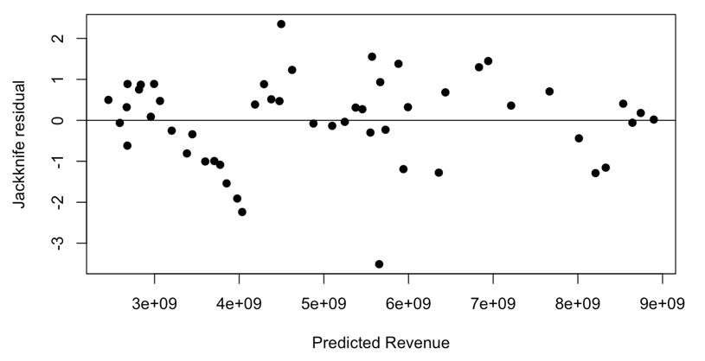
Additionally, a normal probability plot of the data (Figure 6) does not show any significant concave pattern, so normality also holds.

Figure 6
Normal probability plot of final Mastercard model
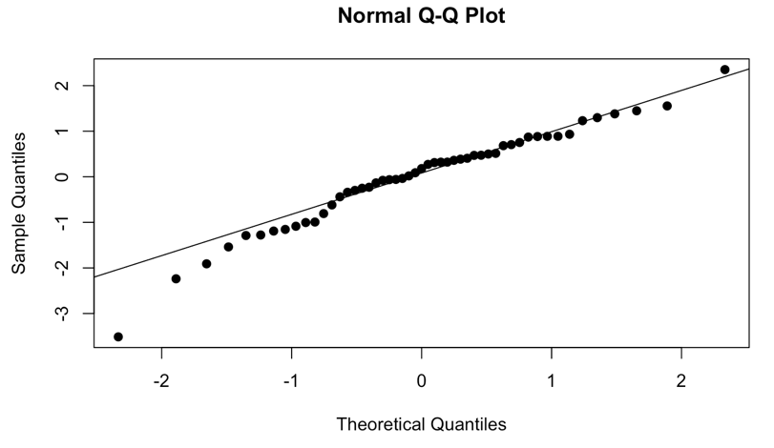

Conclusion
We discovered that Visa’s revenue was best predicted by the following four variables: number of cash transactions, number of purchase transactions, unemployment rate, and three-month interest rate. On the other hand, Mastercard’s revenue could best be predicted by real GDP, CPI less food and energy, unemployment level, and three-month interest rate. Therefore, while the two companies generally showed similar growth patterns, the predictors used were somewhat different.
Interpretation
Three-month interest rate was a common variable both for Visa and Mastercard, even as multiple other predictors were closely correlated with the response variable. Indeed, we found a positive relationship between revenue and three-month interest rate, with a coefficient of 1.55 x 10⁸ for Visa and 1.41 x 10⁸ for Visa. A positive correlation seems counterintuitive at first, since higher interest rates should cause less consumer borrowing and therefore less consumer spending, leading to less revenue generated by credit card companies. However, higher interest rates tend to correlate with credit-card-issuing banks increasing their annual percentage rates (APRs) – the interest paid for carrying balance on a credit card. This could explain the increase in revenue in times of higher interest rates; after all, it was found that Visa had issued over 4.6 billion cards and Mastercard nearly 3.1 billion. With such magnitude, even small increases in APR could lead to significant revenue inflow for the two credit card giants.
Similarly, unemployment rate was identified to be a significant predictor of revenue for Visa while unemployment level was for Mastercard. Given the expectation of the two predictors being very closely related, it seems strange that both would be chosen. However, recalling that our final Visa model was based off the model obtained through stepwise selection, where both unemployment level and rate were included, it can be argued that the difference between the two is minimal. Indeed, because our predictors were determined to be so closely related – collinearity was one of major problems faced – the model likely would not have shown a significant difference had unemployment level been utilized for the Visa model instead of unemployment rate.
Revenue saw a temporary drop in 2020 for both Mastercard and Visa. This is most likely explained by the coronavirus disease (COVID-19) that resulted in an economic downturn as many countries required their citizens to quarantine for some months. During this time, consumer spending decreased and unemployment rate and unemployment level increased, as can be seen in the data analyzed (Appendix C).
Another unusual result found was that Mastercard’s final model included only macroeconomic predictors and no industry-specific ones. In fact, out of the seven total predictors the final model reached with stepwise selection, the only industry-specific predictor was purchase transactions, but it was discovered to have severe collinearity with the other predictors and was therefore removed. There is no clear explanation for this result given that Visa’s final model did contain industry-specific variables. However, it is possible that the decrease in Mastercard’s revenue during COVID-19 corresponded more precisely than Visa’s revenue to the downturns in the predictors such as CPI and unemployment level.
Implications
The scope of this paper was focused on whether two credit card companies’ performances could be predicted from various indicators. As seen, the two final models were not very similar, suggesting variation even within the same industry. Therefore, it does not seem very likely that the results could be generalized beyond each specific company to Discover or American Express, for example. Regardless, the models demonstrate the ability for what seemed to be less closely related variables to predict performance. Knowing this, we could possibly expand our horizons to explore more seemingly distant variables in the future. This could additionally be beneficial by eliminating collinearity that arose from the closely related variables.
Limitations and suggestions for future research
The operational performance data – the cash volume, transactions, cards, and so on – only reached back to 2012 for a total of 51 observations. Therefore, the patterns of the data may not be well-established and therefore may not be as accurate for future data. While this is difficult to remedy considering the lack of exhaustive data, it could be possible that the companies’ performance could be predicted significantly with non-industry-specific data, the possibility of which was seen in the final model obtained for Mastercard.
Additionally, as briefly mentioned during our interpretation of our findings, collinearity was the main problem we aimed to fix in our model selection process. Knowing how closely related nearly all the predictors were similarly results in difficulty extrapolating to future data; a small change in revenue’s rate of growth could change the predictors that best explain it. In the future, finding predictors that cover a wider range of relationships might result in a more ubiquitous model. For example, if Visa or Mastercard is found to be popular among a particular demographic, it could explain a different part of the companies’ performance than economic or industry data.
Another possible research continuation could be to analyze the predictors that best explain American Express or Discover’s revenue, as they could be popular among different demographics than Mastercard or Visa.
References
American Express Company (2024). Financial table. https://s26.q4cdn.com/747928648/files/doc_financials/2024/q3/Q3-2024-Earnings-Tables.pdf
Board of Governors of the Federal Reserve System (US) (n.d.). 3-month treasury bill secondary market rate, discount basis [TB3MS]. Retrieved September 25, 2024, from https://fred.stlouisfed.org/series/TB3MS
Boron, V. R. O., Villarba, L., Murcia, J. V., & Dilema, A. J. (2023). Applying data mining techniques to predict the market performance of publicly traded companies. International Journal of Advanced and Applied Sciences, 10(7), 17-22. https://doi.org/10.21833/ijaas.2023.07.003
Discover Financial Services (2024). Financial supplement. https://s23.q4cdn.com/669804705/files/doc_financials/2024/q3/Third-Quarter-2024-Financial-Supplement.pdf
Federal Reserve Bank of Atlanta (n.d.). Sticky price consumer price index less food and energy [CORESTICKM159SFRBATL]. Retrieved September 25, 2024, from https://fred.stlouisfed.org/series/CORESTICKM159SFRBATL
International Monetary Fund (n.d.). Nominal gross domestic product for United States [NGDPSAXDCUSQ]. Retrieved September 25, 2024, from https://fred.stlouisfed.org/series/NGDPSAXDCUSQ
Issah, M. & Antwi, S. (2017). Role of macroeconomic variables on firms’ performance: Evidence from the UK. Cogent Economics & Finance, 5(1), 1-18. https://doi.org/10.1080/23322039.2017.1405581
Mastercard Incorporated (2024). Mastercard incorporated reports second quarter 2024 financial results. https://s25.q4cdn.com/479285134/files/doc_financials/2024/q2/2Q24-Mastercard-Earnings-Release.pdf
Profit margin by industry. (n.d.). FullRatio. Retrieved October 13, 2024, from https://fullratio.com/profit-margin-by-industry
Seo, W., Kim, B., Bang, S., & Kang, Y. (2024). Identifying key financial variables predicting the financial performance of construction companies. Journal of Construction Engineering and Management, 150(3). https://doi.org/10.1061/JCEMD4.COENG-13959
Stempel, J. (2024, June 25). Visa, MasterCard $30 billion swipe fee settlement rejected by US judge. Reuters. https://www.reuters.com/legal/us-judge-rejects-visa-mastercard-30-bln-swipe-fee-settlement-2024-06-25/
S&P Dow Jones Indices LLC (n.d.). S&P 500 [SP500]. Retrieved September 25, 2024, from https://fred.stlouisfed.org/series/SP500
U.S. Bureau of Economic Analysis (n.d.-a). Personal consumption expenditures [PCE]. Retrieved September 25, 2024, from https://fred.stlouisfed.org/series/PCE
U.S. Bureau of Economic Analysis (n.d.-b). Personal consumption expenditures price index. Retrieved October 27, 2024, from https://www.bea.gov/data/personal-consumption-expenditures-price-index
U.S. Bureau of Economic Analysis (n.d.-c). Real gross domestic product [GDPC1]. Retrieved September 25, 2024, from https://fred.stlouisfed.org/series/GDPC1
U.S. Bureau of Economic Analysis (n.d.-d). Real gross domestic product per capita [A939RX0Q048SBEA]. Retrieved September 25, 2024, from https://fred.stlouisfed.org/series/A939RX0Q048SBEA
U.S. Bureau of Labor Statistics (n.d.-a). Consumer price index for all urban consumers: all items in U.S. city average [CPIAUCSL]. Retrieved September 25, 2024, from https://fred.stlouisfed.org/series/CPIAUCSL
U.S. Bureau of Labor Statistics (n.d.-b). Unemployment rate [UNRATE]. Retrieved September 25, 2024, from https://fred.stlouisfed.org/series/UNRATE
Visa Inc. (2024a). Operational performance data. https://s1.q4cdn.com/050606653/files/doc_financials/2024/q3/Q3FY24-Visa-Operational-Performance-Data-FINAL.pdf
Visa Inc. (2024b). Visa reports fiscal third quarter 2024 results. https://s1.q4cdn.com/050606653/files/doc_financials/2024/q3/Q3-2024-Earnings-Release_vF.pdf

Appendix A
Summary of Visa Data Analyzed
Report Date | Revenue | Cards | Cash Trans | Cash Volume | GDV | Purchase Trans | Purchase Volume
2011-12-31 | 2547000000 | 2011 | 3574 | 595 | 1588 | 16768 | 993
2012-03-31 | 2578000000 | 2025 | 3495 | 584 | 1541 | 16134 | 958
2012-06-30 | 2565000000 | 2016 | 3578 | 591 | 1570 | 16349 | 979
2012-09-30 | 2731000000 | 2066 | 3617 | 608 | 1615 | 16951 | 1007
2012-12-31 | 2846000000 | 2111 | 3802 | 649 | 1723 | 17756 | 1075
2013-03-31 | 2958000000 | 2134 | 3607 | 623 | 1649 | 17132 | 1025
2013-06-30 | 3001000000 | 2159 | 3856 | 650 | 1739 | 18486 | 1089
2013-09-30 | 2973000000 | 2179 | 3912 | 640 | 1745 | 19028 | 1104
2013-12-31 | 3155000000 | 2219 | 4038 | 674 | 1838 | 19613 | 1164
2014-03-31 | 3163000000 | 2253 | 3854 | 622 | 1730 | 18887 | 1108
2014-06-30 | 3155000000 | 2298 | 4071 | 654 | 1845 | 20465 | 1191
2014-09-30 | 3229000000 | 2341 | 4143 | 667 | 1884 | 20923 | 1217
2014-12-31 | 3382000000 | 2402 | 4243 | 654 | 1899 | 21765 | 1245
2015-03-31 | 3409000000 | 2420 | 4051 | 583 | 1751 | 21044 | 1168
2015-06-30 | 3518000000 | 2442 | 4232 | 602 | 1855 | 22709 | 1253
2015-09-30 | 3571000000 | 2459 | 4305 | 584 | 1848 | 23643 | 1265
2015-12-31 | 3565000000 | 2483 | 4360 | 586 | 1890 | 24620 | 1306
2016-03-31 | 3626000000 | 2510 | 4198 | 541 | 1793 | 24010 | 1252
2016-06-30 | 3630000000 | 3086 | 5795 | 759 | 2586 | 35313 | 1828
2016-09-30 | 4261000000 | 3086 | 5804 | 763 | 2622 | 36091 | 1859
2016-12-31 | 4461000000 | 3143 | 5476 | 720 | 2525 | 35405 | 1805
2017-03-31 | 4477000000 | 3158 | 5158 | 684 | 2420 | 34186 | 1736
2017-06-30 | 4565000000 | 3191 | 5429 | 734 | 2599 | 36786 | 1862
2017-09-30 | 4855000000 | 3213 | 5394 | 747 | 2677 | 37686 | 1931
2017-12-31 | 4862000000 | 3250 | 5500 | 762 | 2813 | 39320 | 2051
2018-03-31 | 5073000000 | 3267 | 5320 | 737 | 2755 | 38048 | 2019
2018-06-30 | 5240000000 | 3276 | 5525 | 742 | 2868 | 41207 | 2126
2018-09-30 | 5434000000 | 3347 | 5523 | 723 | 2835 | 42469 | 2112
2018-12-31 | 5506000000 | 3357 | 5582 | 729 | 2926 | 44380 | 2196
2019-03-31 | 5494000000 | 3375 | 5134 | 678 | 2761 | 42207 | 2084
2019-06-30 | 5840000000 | 3400 | 5400 | 705 | 2936 | 46219 | 2231
2019-09-30 | 6137000000 | 3380 | 5418 | 713 | 2983 | 47838 | 2270
2019-12-31 | 6054000000 | 3478 | 5474 | 719 | 3080 | 49288 | 2361
2020-03-31 | 5854000000 | 3469 | 4986 | 645 | 2786 | 45709 | 2141
2020-06-30 | 4837000000 | 3493 | 3756 | 541 | 2494 | 40679 | 1953
2020-09-30 | 5101000000 | 3505 | 4467 | 647 | 2995 | 49649 | 2349
2020-12-31 | 5687000000 | 3592 | 4493 | 641 | 3114 | 51455 | 2473
2021-03-31 | 5729000000 | 3642 | 4227 | 620 | 3043 | 50651 | 2423
2021-06-30 | 6130000000 | 3713 | 4352 | 654 | 3373 | 55203 | 2719
2021-09-30 | 6559000000 | 3834 | 4556 | 678 | 3461 | 58888 | 2783
2021-12-31 | 7059000000 | 3922 | 4524 | 665 | 3630 | 62296 | 2966
2022-03-31 | 7189000000 | 3924 | 4189 | 609 | 3384 | 57121 | 2775
2022-06-30 | 7275000000 | 4053 | 4316 | 614 | 3553 | 59611 | 2939
2022-09-30 | 7787000000 | 4121 | 4362 | 606 | 3535 | 61868 | 2929
2022-12-31 | 7936000000 | 4227 | 4413 | 616 | 3630 | 63297 | 3014
2023-03-31 | 7985000000 | 4201 | 4172 | 596 | 3551 | 60940 | 2955
2023-06-30 | 8123000000 | 4260 | 4314 | 633 | 3799 | 66110 | 3166
2023-09-30 | 8609000000 | 4320 | 4313 | 628 | 3824 | 68441 | 3196
2023-12-31 | 8634000000 | 4434 | 4318 | 634 | 3910 | 70268 | 3276
2024-03-31 | 8775000000 | 4549 | 4159 | 607 | 3780 | 67922 | 3173
2024-06-30 | 8900000000 | 4609 | 4320 | 624 | 3949 | 72655 | 3325

Appendix B
Summary of Mastercard Data Analyzed
Report Date | Revenue | Cards | Cash Trans | Cash Volume | GDV | Purchase Trans | Purchase Volume
2011-12-31 | 1728000000 | 1034 | 1391 | 217 | 864 | 9491 | 648
2012-03-31 | 1758000000 | 1052 | 1425 | 222 | 851 | 9286 | 629
2012-06-30 | 1820000000 | 1072 | 1541 | 232 | 893 | 9900 | 661
2012-09-30 | 1918000000 | 1098 | 1603 | 243 | 919 | 10150 | 676
2012-12-31 | 1895000000 | 1131 | 1685 | 262 | 989 | 10751 | 727
2013-03-31 | 1906000000 | 1168 | 1680 | 258 | 947 | 10252 | 690
2013-06-30 | 2096000000 | 1201 | 1825 | 275 | 1009 | 11203 | 734
2013-09-30 | 2218000000 | 1238 | 1913 | 284 | 1046 | 11735 | 763
2013-12-31 | 2092000000 | 1281 | 1997 | 301 | 1105 | 12159 | 805
2014-03-31 | 2172000000 | 1299 | 1999 | 286 | 1044 | 11694 | 758
2014-06-30 | 2368000000 | 1333 | 2141 | 303 | 1125 | 12755 | 821
2014-09-30 | 2490000000 | 1377 | 2237 | 314 | 1157 | 13182 | 843
2014-12-31 | 2411000000 | 1412 | 2308 | 315 | 1174 | 13902 | 859
2015-03-31 | 2230000000 | 1441 | 2237 | 282 | 1065 | 13464 | 783
2015-06-30 | 2390000000 | 1477 | 2400 | 301 | 1143 | 14712 | 842
2015-09-30 | 2530000000 | 1519 | 2508 | 307 | 1159 | 15335 | 852
2015-12-31 | 2517000000 | 1524 | 2625 | 318 | 1201 | 16174 | 883
2016-03-31 | 2446000000 | 1557 | 2598 | 307 | 1143 | 15827 | 836
2016-06-30 | 2694000000 | 1584 | 2769 | 333 | 1230 | 16963 | 897
2016-09-30 | 2880000000 | 1608 | 2819 | 338 | 1219 | 16856 | 881
2016-12-31 | 2756000000 | 1651 | 2809 | 331 | 1230 | 17577 | 898
2017-03-31 | 2734000000 | 1687 | 2712 | 320 | 1182 | 17089 | 863
2017-06-30 | 3053000000 | 1726 | 2911 | 353 | 1285 | 18649 | 932
2017-09-30 | 3398000000 | 1778 | 2964 | 373 | 1355 | 19516 | 982
2017-12-31 | 3312000000 | 1825 | 3073 | 383 | 1420 | 20542 | 1038
2018-03-31 | 3580000000 | 1837 | 2986 | 376 | 1404 | 20192 | 1028
2018-06-30 | 3665000000 | 1878 | 3180 | 388 | 1471 | 22230 | 1083
2018-09-30 | 3898000000 | 1931 | 3212 | 386 | 1469 | 23130 | 1082
2018-12-31 | 3807000000 | 1999 | 3358 | 403 | 1549 | 24736 | 1146
2019-03-31 | 3889000000 | 2049 | 3256 | 391 | 1483 | 23930 | 1091
2019-06-30 | 4113000000 | 2093 | 3485 | 421 | 1601 | 26820 | 1181
2019-09-30 | 4467000000 | 2139 | 3564 | 435 | 1653 | 28191 | 1219
2019-12-31 | 4414000000 | 2172 | 3675 | 455 | 1731 | 29428 | 1277
2020-03-31 | 4009000000 | 2212 | 3370 | 414 | 1565 | 27455 | 1150
2020-06-30 | 3335000000 | 2229 | 2696 | 346 | 1383 | 24802 | 1037
2020-09-30 | 3837000000 | 2275 | 3212 | 412 | 1648 | 29809 | 1236
2020-12-31 | 4120000000 | 2334 | 3240 | 426 | 1747 | 30973 | 1321
2021-03-31 | 4155000000 | 2390 | 3114 | 415 | 1711 | 30085 | 1296
2021-06-30 | 4528000000 | 2449 | 3217 | 439 | 1904 | 34121 | 1466
2021-09-30 | 4985000000 | 2503 | 3339 | 450 | 1993 | 36790 | 1543
2021-12-31 | 5216000000 | 2588 | 3431 | 458 | 2113 | 38898 | 1655
2022-03-31 | 5167000000 | 2517 | 3103 | 402 | 1919 | 33756 | 1517
2022-06-30 | 5497000000 | 2589 | 3182 | 404 | 2054 | 36554 | 1650
2022-09-30 | 5756000000 | 2662 | 3244 | 400 | 2069 | 38929 | 1669
2022-12-31 | 5817000000 | 2731 | 3258 | 406 | 2133 | 40248 | 1727
2023-03-31 | 5748000000 | 2769 | 3090 | 401 | 2108 | 38814 | 1707
2023-06-30 | 6269000000 | 2834 | 3237 | 428 | 2267 | 42371 | 1839
2023-09-30 | 6533000000 | 2882 | 3244 | 426 | 2305 | 44073 | 1880
2023-12-31 | 6548000000 | 2944 | 3245 | 432 | 2352 | 45307 | 1920
2024-03-31 | 6348000000 | 3006 | 3113 | 421 | 2290 | 43977 | 1869
2024-06-30 | 6961000000 | 3054 | 3213 | 430 | 2403 | 47382 | 1973

Appendix C
Summary of Macroeconomic Data Analyzed
Report Date | S&P 500 | Nom. GDP | Real GDP | Real GDP per cap. | CPI | CPI less food + energy | Pers. Cons. | Unemp. Rate | Unemp. Level | 3 mth Int | 10 Year Int
2011-12-31 | 125.5 | 15842.259 | 17222.583 | 54979 | 227.223 | 2.045078 | 10817.8 | 8.5 | 13093 | 0.02 | 1.89
2012-03-31 | 140.81 | 16068.805 | 17367.01 | 55342 | 228.807 | 2.122799 | 10993.9 | 8.2 | 12713 | 0.07 | 2.23
2012-06-30 | 136.1 | 16207.115 | 17444.525 | 55490 | 228.524 | 2.238927 | 10989.8 | 8.2 | 12692 | 0.09 | 1.67
2012-09-30 | 143.97 | 16319.541 | 17469.65 | 55454 | 231.015 | 2.219253 | 11105.3 | 7.8 | 12115 | 0.1 | 1.65
2012-12-31 | 142.41 | 16420.419 | 17489.852 | 55403 | 231.221 | 2.107127 | 11181.2 | 7.9 | 12298 | 0.05 | 1.78
2013-03-31 | 156.67 | 16648.189 | 17662.4 | 55859 | 232.282 | 2.096923 | 11290.1 | 7.5 | 11689 | 0.07 | 1.87
2013-06-30 | 160.42 | 16728.687 | 17709.671 | 55914 | 232.445 | 1.874046 | 11344.4 | 7.5 | 11751 | 0.04 | 2.52
2013-09-30 | 168.01 | 16953.838 | 17860.45 | 56272 | 233.544 | 1.888205 | 11445.9 | 7.2 | 11270 | 0.02 | 2.64
2013-12-31 | 184.69 | 17192.019 | 18016.147 | 56642 | 234.719 | 1.872378 | 11593.2 | 6.7 | 10404 | 0.07 | 3.04
2014-03-31 | 187.01 | 17197.738 | 17953.974 | 56345 | 236.028 | 1.821445 | 11722.3 | 6.7 | 10380 | 0.05 | 2.73
2014-06-30 | 195.72 | 17518.508 | 18185.911 | 56968 | 237.231 | 2.142724 | 11861.7 | 6.1 | 9460 | 0.04 | 2.53
2014-09-30 | 197.02 | 17804.228 | 18406.941 | 57536 | 237.477 | 1.95017 | 11991.4 | 5.9 | 9262 | 0.02 | 2.52
2014-12-31 | 205.54 | 17912.079 | 18500.031 | 57702 | 236.252 | 1.961226 | 12096.1 | 5.6 | 8717 | 0.04 | 2.17
2015-03-31 | 206.43 | 18063.529 | 18666.621 | 58121 | 235.976 | 1.989606 | 12176.1 | 5.4 | 8515 | 0.03 | 1.94
2015-06-30 | 205.89 | 18279.784 | 18782.243 | 58376 | 237.657 | 2.103732 | 12307.9 | 5.3 | 8247 | 0.01 | 2.35
2015-09-30 | 191.59 | 18401.626 | 18857.418 | 58486 | 237.498 | 2.268536 | 12386.4 | 5.0 | 7907 | -0.01 | 2.06
2015-12-31 | 203.87 | 18435.137 | 18892.206 | 58470 | 237.761 | 2.437497 | 12452.0 | 5.0 | 7907 | 0.16 | 2.27
2016-03-31 | 205.52 | 18525.933 | 19001.69 | 58704 | 238.08 | 2.526214 | 12537.0 | 5.0 | 7961 | 0.21 | 1.78
2016-06-30 | 209.48 | 18711.702 | 19062.709 | 58787 | 240.222 | 2.563629 | 12731.2 | 4.9 | 7744 | 0.26 | 1.49
2016-09-30 | 216.3 | 18892.639 | 19197.938 | 59084 | 241.176 | 2.624799 | 12846.6 | 5.0 | 7953 | 0.28 | 1.6
2016-12-31 | 223.53 | 19089.379 | 19304.352 | 59296 | 242.637 | 2.585286 | 13005.9 | 4.7 | 7521 | 0.5 | 2.45
2017-03-31 | 235.74 | 19280.084 | 19398.343 | 59494 | 243.892 | 2.436586 | 13139.9 | 4.4 | 7073 | 0.75 | 2.4
2017-06-30 | 241.8 | 19438.643 | 19506.949 | 59736 | 244.163 | 2.122109 | 13225.2 | 4.3 | 6873 | 1.01 | 2.31
2017-09-30 | 251.23 | 19692.595 | 19660.766 | 60099 | 246.435 | 2.091354 | 13417.3 | 4.3 | 6854 | 1.04 | 2.33
2017-12-31 | 266.86 | 20037.088 | 19882.352 | 60674 | 247.805 | 2.117186 | 13666.1 | 4.1 | 6632 | 1.37 | 2.4
2018-03-31 | 263.15 | 20328.553 | 20044.077 | 61093 | 249.577 | 2.366925 | 13793.2 | 4.0 | 6472 | 1.7 | 2.74
2018-06-30 | 271.28 | 20580.912 | 20150.476 | 61336 | 251.018 | 2.551897 | 13930.4 | 4.0 | 6447 | 1.89 | 2.85
2018-09-30 | 290.72 | 20798.73 | 20276.154 | 61622 | 252.182 | 2.462881 | 14017.8 | 3.7 | 6073 | 2.15 | 3.05
2018-12-31 | 249.92 | 20917.867 | 20304.874 | 61619 | 252.767 | 2.456173 | 14051.6 | 3.9 | 6389 | 2.4 | 2.69
2019-03-31 | 282.48 | 21111.6 | 20431.641 | 61939 | 254.277 | 2.356946 | 14240.1 | 3.8 | 6202 | 2.35 | 2.41
2019-06-30 | 293.0 | 21397.938 | 20602.275 | 62385 | 255.213 | 2.392597 | 14391.2 | 3.6 | 5935 | 2.08 | 2.0
2019-09-30 | 296.77 | 21717.171 | 20843.322 | 63022 | 256.43 | 2.622934 | 14555.6 | 3.5 | 5753 | 1.84 | 1.68
2019-12-31 | 321.86 | 21933.217 | 20985.448 | 63360 | 258.63 | 2.752609 | 14741.3 | 3.6 | 5853 | 1.52 | 1.92
2020-03-31 | 257.75 | 21727.657 | 20693.238 | 62416 | 258.15 | 2.606553 | 13793.0 | 4.4 | 7209 | 0.11 | 0.7
2020-06-30 | 308.36 | 19935.444 | 19056.617 | 57449 | 257.004 | 1.993544 | 14027.1 | 11.0 | 17658 | 0.16 | 0.66
2020-09-30 | 334.89 | 21684.551 | 20548.793 | 61915 | 259.951 | 1.980283 | 14655.0 | 7.8 | 12573 | 0.1 | 0.69
2020-12-31 | 373.88 | 22068.767 | 20771.691 | 62554 | 262.005 | 1.600671 | 14801.8 | 6.7 | 10772 | 0.09 | 0.93
2021-03-31 | 396.33 | 22656.793 | 21058.379 | 63428 | 264.91 | 1.592366 | 15657.6 | 6.1 | 9734 | 0.03 | 1.74
2021-06-30 | 428.06 | 23368.861 | 21389.005 | 64392 | 270.664 | 2.558145 | 16108.5 | 5.9 | 9547 | 0.05 | 1.45
2021-09-30 | 429.14 | 23921.991 | 21571.421 | 64877 | 273.887 | 2.610662 | 16398.9 | 4.7 | 7659 | 0.04 | 1.52
2021-12-31 | 474.96 | 24777.038 | 21960.388 | 65986 | 280.808 | 3.456458 | 16799.2 | 3.9 | 6305 | 0.06 | 1.52
2022-03-31 | 451.64 | 25215.491 | 21903.85 | 65779 | 287.553 | 4.534344 | 17203.6 | 3.6 | 5993 | 0.51 | 2.32
2022-06-30 | 377.25 | 25805.791 | 21919.222 | 65760 | 294.996 | 5.39633 | 17550.0 | 3.6 | 5984 | 1.66 | 2.98
2022-09-30 | 357.18 | 26272.011 | 22066.784 | 66115 | 296.341 | 6.348017 | 17804.0 | 3.5 | 5755 | 3.22 | 3.83
2022-12-31 | 382.43 | 26734.277 | 22249.459 | 66575 | 298.812 | 6.538167 | 17943.6 | 3.5 | 5698 | 4.3 | 3.88
2023-03-31 | 409.39 | 27164.359 | 22403.435 | 66967 | 301.744 | 6.390946 | 18282.6 | 3.5 | 5866 | 4.68 | 3.48
2023-06-30 | 443.28 | 27453.815 | 22539.418 | 67295 | 304.003 | 5.586684 | 18485.4 | 3.6 | 5997 | 5.17 | 3.81
2023-09-30 | 427.48 | 27967.697 | 22780.933 | 67916 | 307.288 | 4.95977 | 18791.5 | 3.8 | 6347 | 5.32 | 4.59
2023-12-31 | 475.31 | 28296.967 | 22960.6 | 68351 | 308.742 | 4.554396 | 19013.7 | 3.7 | 6268 | 5.2 | 3.88
2024-03-31 | 523.07 | 28624.069 | 23053.545 | 68549 | 312.23 | 4.509212494 | 19263.7 | 3.8 | 6429 | 5.23 | 4.2
2024-06-30 | 544.22 | 29016.714 | 23223.906 | 68977 | 313.049 | 4.226875782 | 19476.7 | 4.1 | 6811 | 5.22 | 4.36

